Unit 1 Let Me Introduce Myself

A
2. I’m in the fifth grade.
3. I’m in the third grade.
4. I’m in the second grade.

B
2. I like to play tennis with my family.
3. I love to play soccer with my friends.
4. I like to bake cakes and cookies.

C
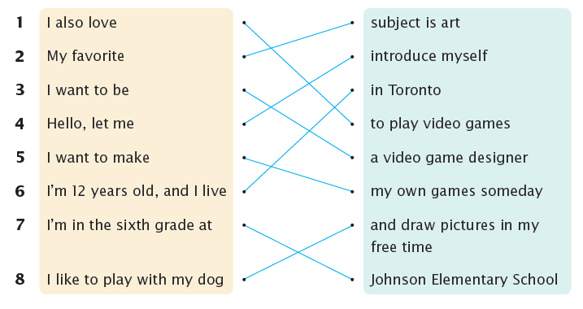
1. I also love to play video games.
2. My favorite subject is art.
3. I want to be a video game designer.
4. Hello, let me introduce myself.
5. I want to make my own games someday.
6. I’m 12 years old, and I live in Toronto.
7. I’m in the sixth grade at Johnson Elementary School.
8. I like to play with my dog and draw pictures in my free time.

Unit 2 This Is My Family

A
2. My grandfather is quiet, but he is funny.
3. My grandmother is noisy, but she is very cool.
4. My aunt is thin, but she is very strong.

B
2. He is good at doing magic tricks.
3. He is good at dancing.
4. She is good at baking bread.

C
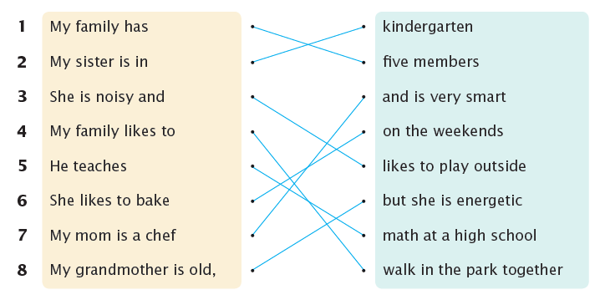

1. My family has five members.
2. My sister is in kindergarten.
3. She is noisy and likes to play outside.
4. My family likes to walk in the park together.
5. He teaches math at a high school.
6. She likes to bake on the weekends.
7. My mom is a chef and is very smart.
8. My grandmother is old, but she is energetic.

Unit 3 Join Our Club

A
2. At the juggling club, we learn how to juggle bean bags, balls, and rings.
3. At the swimming club, we learn how to float, swim, and dive.
4. At the drama club, we learn how to act, sing, and dance on a stage.

B
2. Twice a year, we put on a play for the whole school.
3. Three times a year, we have an art show for the whole school.
4. Once a year, we put on a juggling show for the whole school.

C
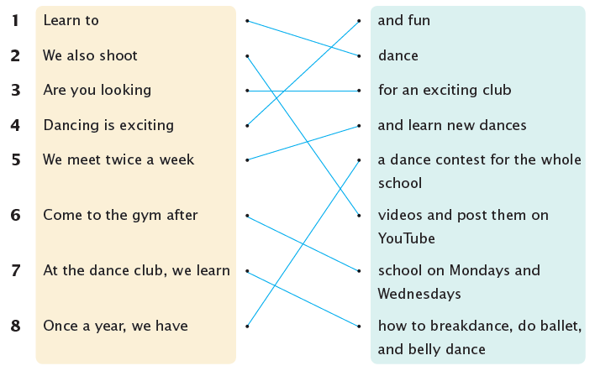

1. Learn to dance!
2. We also shoot videos and post them on YouTube.
3. Are you looking for an exciting club?
4. Dancing is exciting and fun.
5. We meet twice a week and learn new dances.
6. Come to the gym after school on Mondays and Wednesdays.
7. At the dance club, we learn how to breakdance, do ballet, and belly dance.
8. Once a year, we have a dance contest for the whole school.

Unit 4 I Like My New Room

A
2. There is a blue curtain over the window.
3. There is a tall bookshelf across from the bed.
4. There is a large desk next to the bookshelf.

B
2. My curtain is over the window.
3. My bookshelf is next to the desk.
4. My desk is in front of the bookshelf.

C
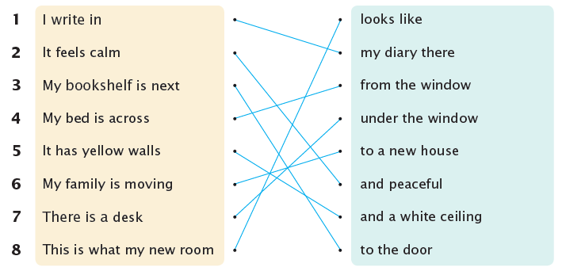

1. I write in my diary there.
2. It feels calm and peaceful.
3. My bookshelf is next to the door.
4. My bed is across from the window.
5. It has yellow walls and a white ceiling.
6. My family is moving to a new house.
7. There is a desk under the window.
8. This is what my new room looks like.

Unit 5 This Is My Best Friend

A
2. Her hair is as long as mine.
3. She is as thin as I am.
4. His hair is as curly as mine.

B
2. Our friends think that we look like brothers.
3. Our friends think that we look like sisters.
4. Our friends think that we look like cousins.

C
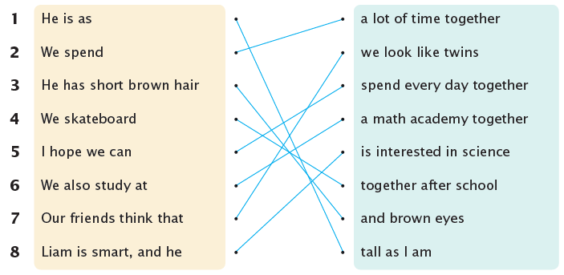

1. He is as tall as I am.
2. We spend a lot of time together.
3. He has short brown hair and brown eyes.
4. We skateboard together after school.
5. I hope we can spend every day together.
6. We also study at a math academy together.
7. Our friends think that we look like twins.
8. Liam is smart, and he is interested in science.

Unit 6 My Trip

A
2. We’re going to watch a musical.
3. We’re going to see the flowers.
4. We’re going to buy some crafts.

B
2. We’ll have pepperoni pizza after we see the musical.
3. We’ll have roast duck after we shop.
4. We’ll have Egyptian pancakes after we shop.

C
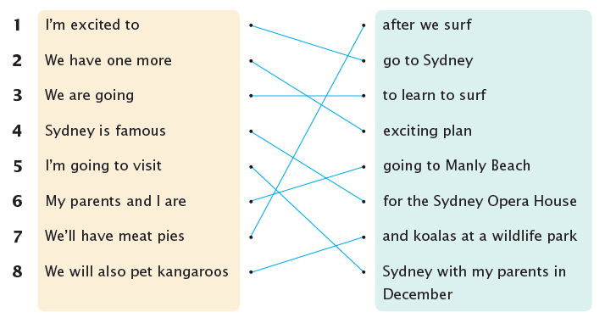

1. I’m excited to go to Sydney!
2. We have one more exciting plan.
3. We are going to learn to surf.
4. Sydney is famous for the Sydney Opera House.
5. I’m going to visit Sydney with my parents in December.
6. My parents and I are going to Manly Beach.
7. We’ll have meat pies after we surf.
8. We will also pet kangaroos and koalas at a wildlife park.

Unit 7 Come to My Party

A
2. It starts at 2:00 P.M.
3. It starts at 4:00 P.M.
4. It starts at 7:00 P.M.

B
2. Can you bring a swimsuit and a towel with you?
3. Can you bring some food with you?
4. Can you bring a costume with you?

C
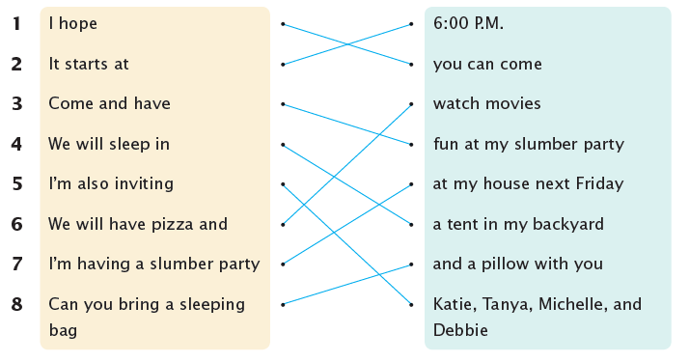

1. I hope you can come.
2. It starts at 6:00 P.M.
3. Come and have fun at my slumber party!
4. We will sleep in a tent in my backyard.
5. I’m also inviting Katie, Tanya, Michelle, and Debbie.
6. We will have pizza and watch movies.
7. I’m having a slumber party at my house next Friday.
8. Can you bring a sleeping bag and a pillow with you?

Unit 8 An Easy Recipe

A
2. Chop the vegetables and meat.
3. Pour some oil into a pan.
4. Mix the eggs and milk.

B
2. Stir the eggs until they are firm.
3. Fry the rice until it is hot.
4. Boil the curry until it is cooked.

C
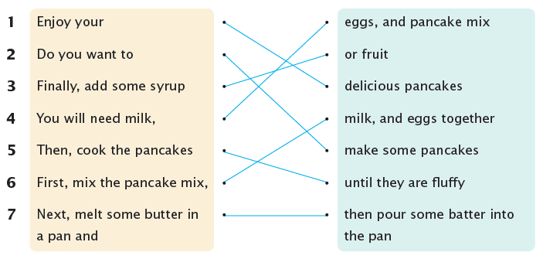

1. Enjoy your delicious pancakes!
2. Do you want to make some pancakes?
3. Finally, add some syrup or fruit.
4. You will need milk, eggs, and pancake mix.
5. Then, cook the pancakes until they are fluffy.
6. First, mix the pancake mix, milk, and eggs together.
7. Next, melt some butter in a pan and then pour some batter into the pan.

